Sql project

Sales database management Name : Shaire raza choudhari

Course : master in data science and data analytics whith ai

ABOUT DATASET:

This dataset provides a comprehensive snapshot of a sales domain, comprising five interconnected tables: Customers, Products, SalesReps, Orders, and OrderDetails.

Available tables:

* **Customers Table**: Contains details about customers, including their ID, name, contact information, and city.
* **Products Table**: Includes information about products such as their ID, name, category, price, and stock levels.
* **SalesReps Table**: Lists sales representatives along with their ID, name, region, and contact number.
* **Orders Table**: Records orders made by customers, including order ID, date, customer ID, and sales rep ID.
* **OrderDetails Table**: Provides detailed information about each order, such as order ID, product ID, quantity, and total price.

ER DIGRAM:

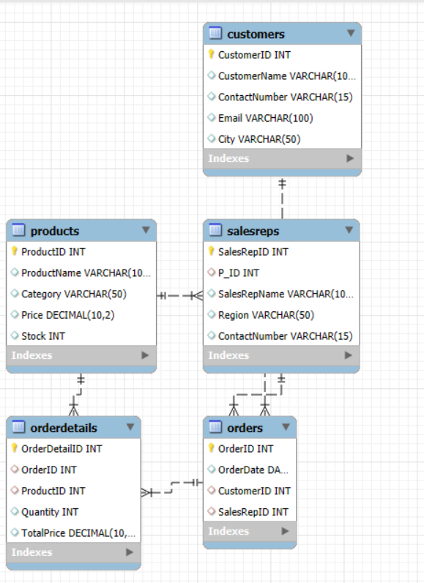

QUERIES:

1. **Display the lowest rate product from electronics**.

select * from products where category="electronics" order by price limit 1;

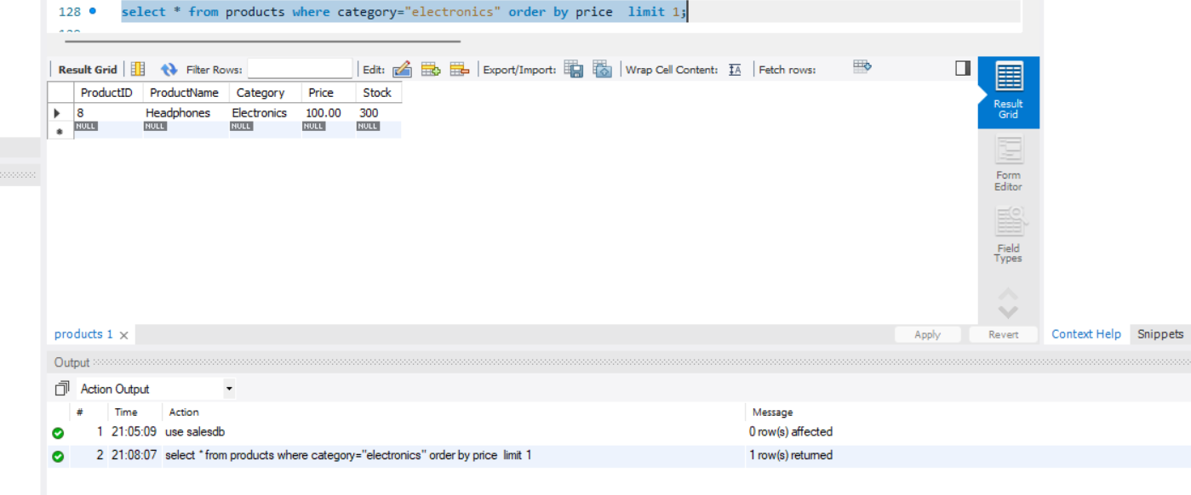

**2.Display the total number of products sold for each category**.

SELECT Category, SUM(OD.Quantity) AS TotalQuantitySold

FROM Products as P

JOIN OrderDetails OD ON P.ProductID = OD.ProductID

GROUP BY P.Category;

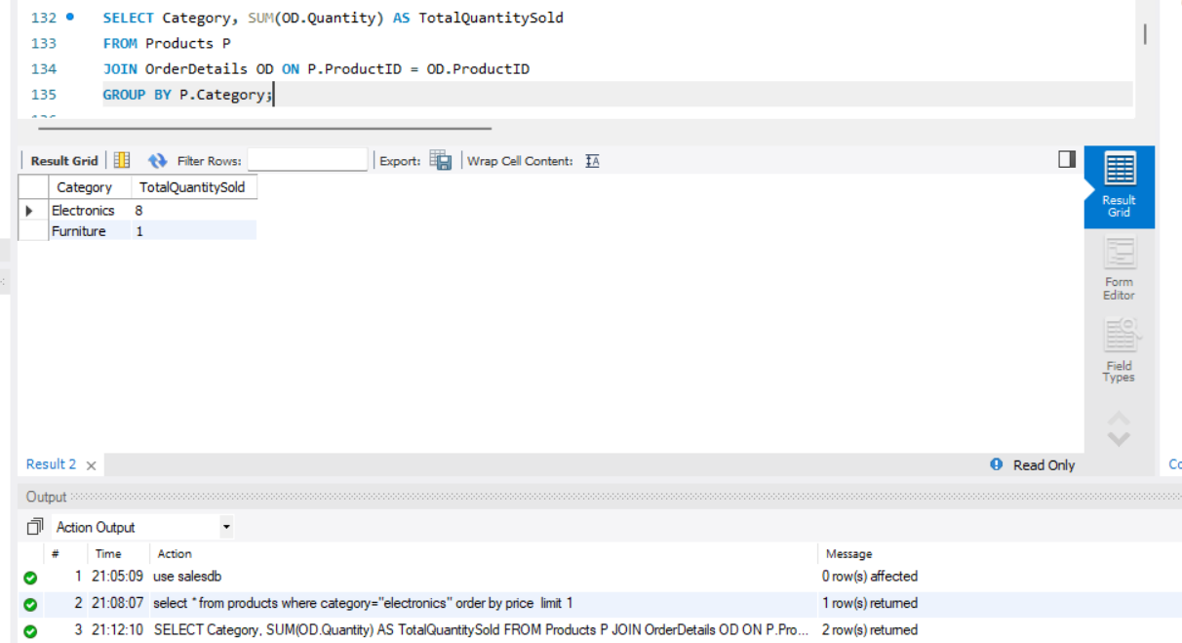

**3.Display OrderID and TotalPrice of the order with the highest total price.**

SELECT OD.OrderID, SUM(OD.TotalPrice) AS TotalPrice

FROM OrderDetails as OD GROUP BY OD.OrderID

ORDER BY TotalPrice DESC LIMIT 1;

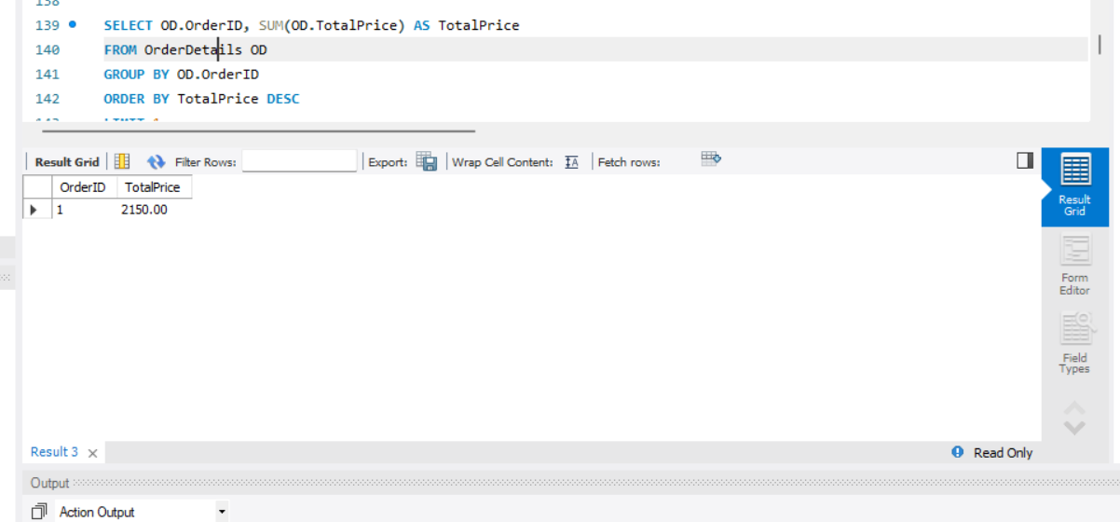

**4.Display customerid and customername whoe dosn't placed any order.**

SELECT C.CustomerID, C.CustomerName

FROM Customers C LEFT JOIN Orders O ON C.CustomerID = O.CustomerID WHERE O.OrderID IS NULL;

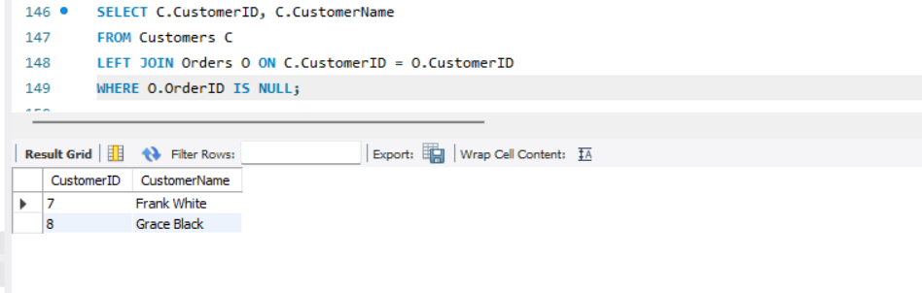

**5.Display productid and productname from product that have not been sold.**

**SELECT P.ProductID, P.ProductName**

**FROM Products as P LEFT JOIN OrderDetails OD ON P.ProductID = OD.ProductID WHERE OD.ProductID IS NULL;**

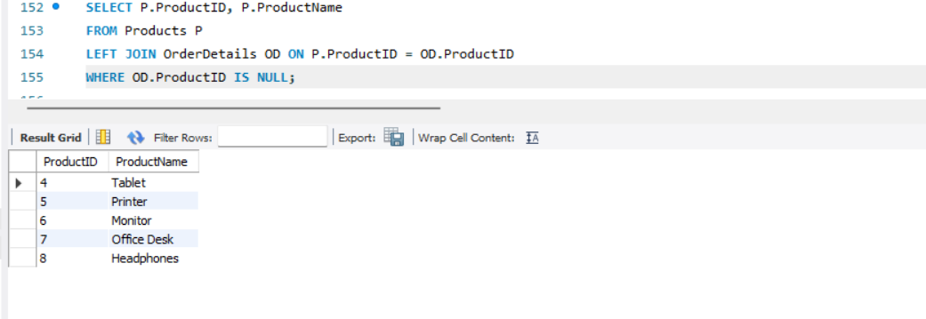

**6.Display orderid,productname and orderdate of the earlist order placed.**

SELECT OrderID,productname, OrderDate

FROM Orders,products

ORDER BY OrderDate ASC

LIMIT 1;

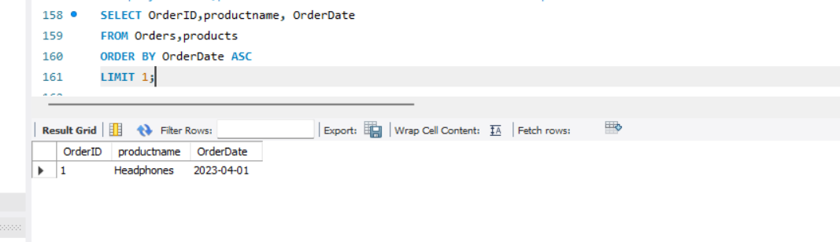

**7.Display productid and productname from the product with the highest stocks.**

SELECT ProductID, ProductName

FROM Products

ORDER BY Stock DESC

LIMIT 1;

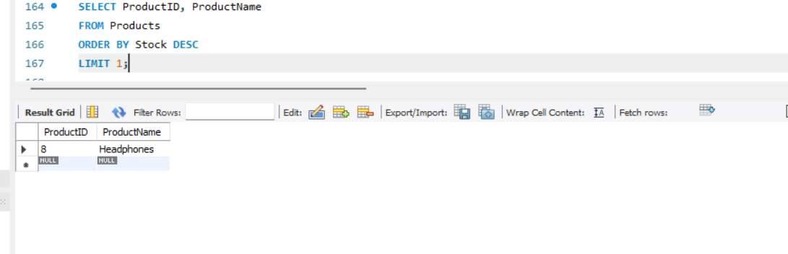

**8.Displey productid and productname of the electronics product of highest price.**

SELECT ProductID, ProductName

FROM Products

ORDER BY Price DESC

LIMIT 1;

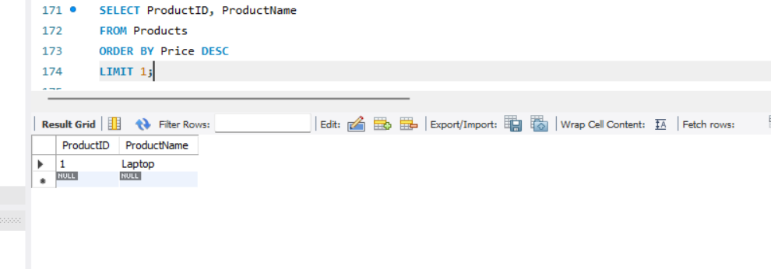

**9.** **Display customer name who buy product from sales person name.**

SELECT O.OrderID, O.OrderDate, C.CustomerName, sr.salesrepname

FROM Orders as O

INNER JOIN Customers as C ON O.CustomerID = C.CustomerID

INNER JOIN SalesReps SR ON O.SalesRepID = SR.SalesRepID;

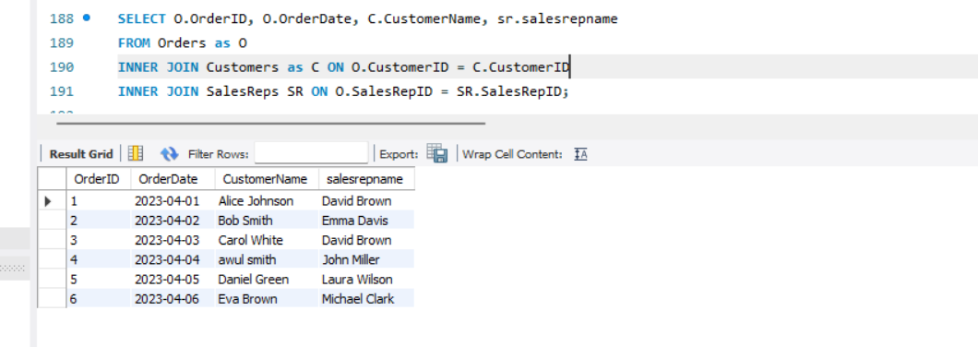

**10.Display order detail from product name.**

SELECT OD.OrderDetailID, O.OrderID, P.ProductName, OD.Quantity, OD.TotalPrice

FROM OrderDetails OD

INNER JOIN Orders AS O ON OD.OrderID = O.OrderID

INNER JOIN Products as P ON OD.ProductID = P.ProductID;

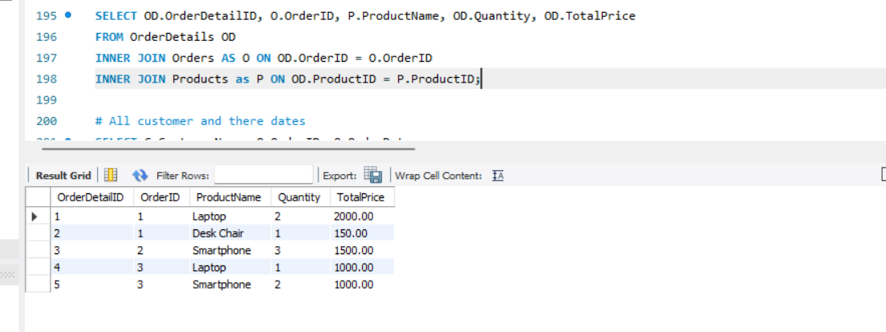

**11.Calculate the total sales of each salesrep.**

SELECT SR.SalesRepName, SUM(OD.TotalPrice) AS TotalRevenue

FROM SalesReps SR

LEFT JOIN Orders O ON SR.SalesRepID = O.SalesRepID

LEFT JOIN OrderDetails OD ON O.OrderID = OD.OrderID

GROUP BY SR.SalesRepName;

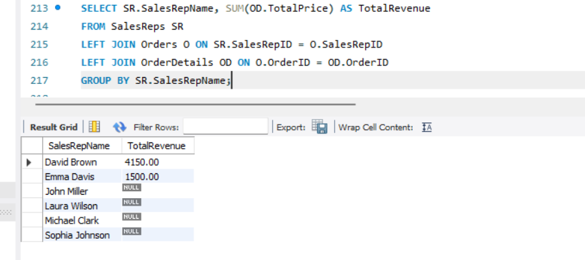

**12.Display all customer with his order dates**.

SELECT C.CustomerName, O.OrderID, O.OrderDate

FROM Customers as C LEFT OUTER JOIN Orders as O ON C.CustomerID = O.CustomerID;

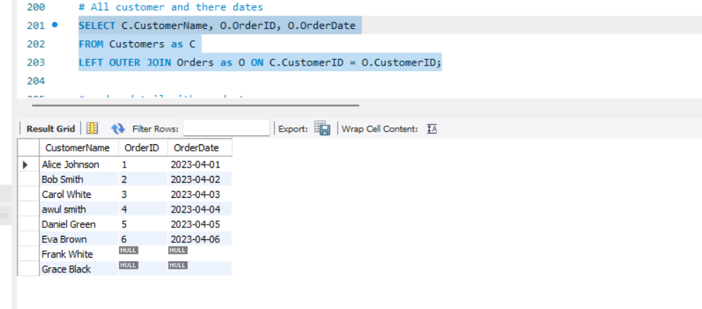

**CONCLUSION:**

The SalesDB dataset provides a comprehensive view of a sales operation, comprising detailed information about customers, products, sales representatives, orders, and order details. This dataset facilitates in-depth analysis of sales performance, customer behavior, product popularity, and sales representative effectiveness. Key insights reveal high revenue from electronics, active customer engagement, and significant contributions by top-performing sales reps. This data can drive strategic decisions to optimize sales processes, enhance customer relationships, and improve inventory management, ultimately leading to sustained business growth and profitability.